**Use Case Description**

**Ex No :**

**Date :**

**Aim:**

To describe the use cases and draw the use case diagram for Attendance Management System.

**Notations :** 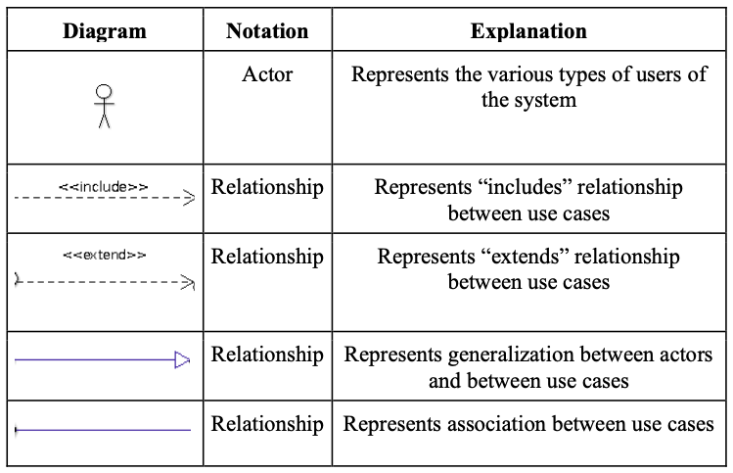

**Use case diagram:** 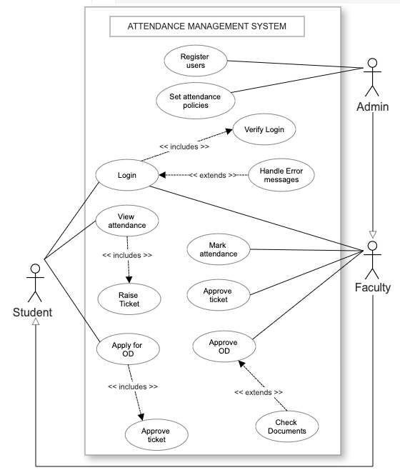

**Scope:** Attendance Management System

**Primary Actors:** Faculties, Students

**Stakeholders and Interests:**

* **ADMIN** - wants a user-friendly application that can maintain attendance records of students. Admin can create login credentials for the users and view the attendance at any time. Admin can also change attendance policies like setting the minimum attendance benchmark.
* **STUDENT** - wants to view their attendance for each course. Students can also raise queries claiming attendance. Moreover, students can apply for OD by submitting the required documents.
* **INSTRUCTOR** - wants an automated application that manages the attendance records. Instructors can mark attendance, view attendance and accept/reject OD applications.

**Main Success Scenario:**

1. Admin generates the login credentials for instructors and students.
2. Admin sets attendance policies.
3. Instructor opens the AMS application.
4. Instructor tries to log into the application using his/her credentials.
5. Username/Email is validated with the password and access is granted.
6. Instructor marks the attendance and gets the consolidated record.
7. Students open the AMS application.
8. Student tries to log into the application using his/her credentials.
9. Username/Email is validated with the password and access is granted.
10. Student views his/her attendance record/leave history.
11. Student raises a ticket claiming attendance.
12. Instructor accepts the claim and the record gets updated.
13. Students fill out the application for OD.
14. Instructor accepts the application and the record gets updated.

**Special Requirements:**

1. Internet connectivity

2. System should be capable of handling a user load of around 100 students.

3. Robust recovery in case of any failure.